 | Assignment No. 03  Semester: Fall 2011  CS302: Digital Logic Design |  | Total Marks: 10  Due Date: 27/12/2011
Instructions:
Please read the following instructions carefully before submitting assignment:
It should be clear that your assignment will not get any credit if:

- The assignment is submitted after due date.
- The assignment is submitted via email.
- The submitted assignment does not open or file is corrupt.
- All types of plagiarism are strictly prohibited.

Objectives:

This assignment has been designed to enable you to understand the concepts of:

- SR Latch
- Flip Flops
- Flip-flops with asynchronous inputs

Guidelines:

- Perform/write all steps while solving the problems.

Assignment
Question No. 1 [Marks: 5]

Complete the table given below for NAND based SR latch. Assume that Q output is initially 1.

EN | S | R | Q_{t+1}
0 | 1 | 0 | ?
0 | 0 | 1 | ?
1 | 1 | 0 | ?
1 | 1 | 1 | ?
0 | 0 | 1 | ?

Question No. 2 [Marks: 5]

Determine Q output waveform for a negative edge triggered J-K flip-flop with preset, clear and J, K inputs. You are required to draw Q output waveform using timing diagram.

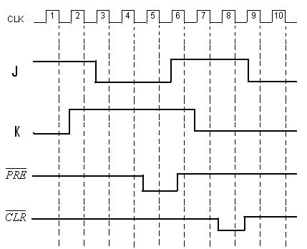

Deadline:
Your assignment must be uploaded/submitted on or before 27th Dec, 2011

